Signals and systems

Lab 01

3190102060 黄嘉欣

**Problem 1**

Solutions:

1. Drawing by MATLAB, we can get a figure of the signals as follows:

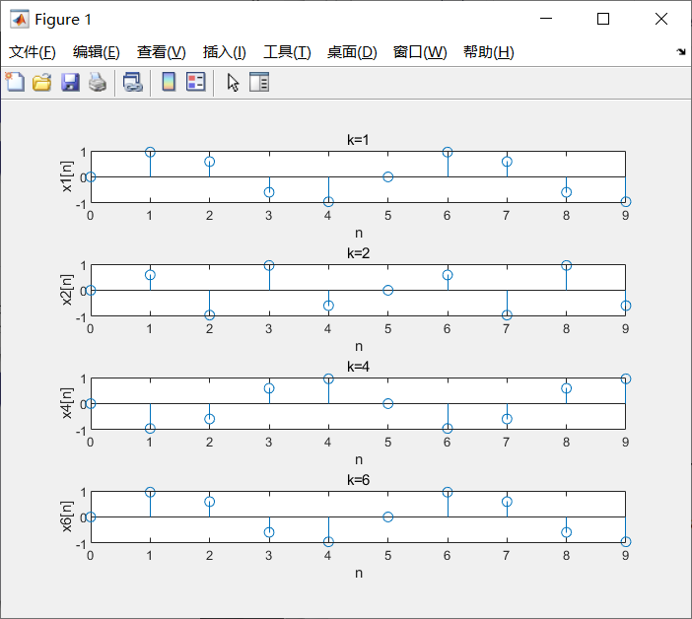

Figure 1.1

It is obvious that there are **3** unique signals, and $x_{1}[n]$ and $x_{6}[n]$ are identical.

1. According to the figure we get in this problem, $x_{1}[n]$ and $x_{6}[n]$ are the same signals and the different value of $ω_{1}$ and $ω_{6}$ is

$$\frac{12}{5}π−\frac{2}{5}π=2π$$

More generally, we have known that

$$x_{k}[n]=sin(ω_{k}n)=sin(ω_{k}n+2nπ)=sin((ω_{k}+2π)n)$$

Let $ω_{m}=ω_{k}$ $+$ 2 $π$, we have

$$x_{k}[n] = sin(ω_{m}n) = x_{m}[n]$$

which shows that when the different values of $ω_{k}$ are **2 $π$**, the signals are identical.

MATLAB code:

% prob1.m

clc;

clear;

k=[1,2,4,6];

n=0:9;

wk=2*pi*k/5;

x=sin(wk'*n);

% k=1

subplot(4,1,1);

stem(n,x(1,:));

title('k=1');

xlabel('n');

ylabel('x1[n]');

% k=2

subplot(4,1,2);

stem(n,x(2,:));

title('k=2');

xlabel('n');

ylabel('x2[n]');

% k=4

subplot(4,1,3);

stem(n,x(3,:));

title('k=4');

xlabel('n');

ylabel('x4[n]');

% k=6

subplot(4,1,4);

stem(n,x(4,:));

title('k=6');

xlabel('n');

ylabel('x6[n]');

**Problem 2**

Solutions:

Substitute N = 6 into the expressions, we can get the three signals as:

$$x_{1}[n]=cos(\frac{nπ}{3})+2cos(\frac{nπ}{2})$$

$$x_{2}[n]=2cos(\frac{n}{3})+cos(\frac{n}{2})$$

$$x_{3}[n]=cos(\frac{nπ}{3})+3sin(\frac{5nπ}{12})$$

1. Since the periods of $cos(\frac{nπ}{3})$ and $cos(\frac{nπ}{2})$ are

$$T_{1}=\frac{2π×3}{π}=6$$

$$T_{2}=\frac{2π×2}{π}=4$$

which are integers, we have

$\frac{T_{1}}{T_{2}}=1.$ 5

so $x_{1}[n]$ is a periodic signal and its period is the least common multiple of 4 and 6, that is,

$$T=12$$

Then, we can get the figure of the signal for two periods by MATLAB as follows:

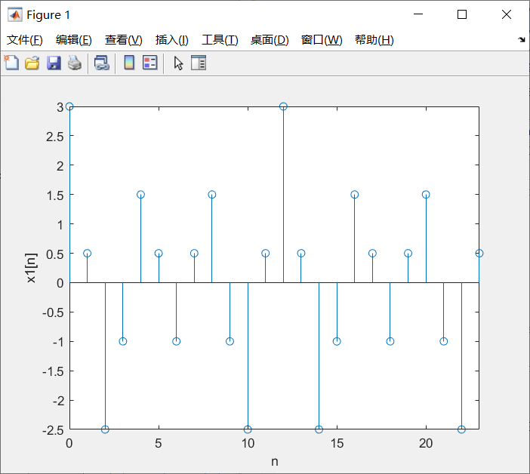

Figure 2.1 image of $x_{1}[n]$

1. Since $\frac{2π}{ω}$ of $cos(\frac{n}{3})$ and $cos(\frac{n}{2})$ are

$$T_{1}=2π×3=6π$$

$$T_{2}=2π×2=4π$$

which are not rational numbers, so $cos(\frac{n}{3})$ and $cos(\frac{n}{2})$ are not periodic. This is because $n$ should be an integer, which determines the sampling period should also be an integer. In addition, as a linear combination of the two parts, $x_{2}[n]$ is not a periodic signal, either.

Then, we can get the figure of the signal for $0≤n≤24$ by MATLAB as follows:

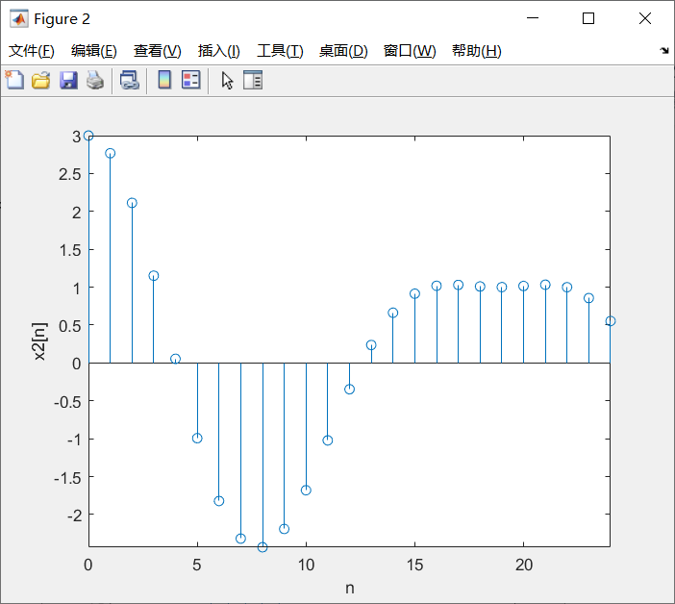

Figure 2.2 image of $x_{2}[n]$

1. Since the periods of $cos(\frac{nπ}{3})$ and $sin(\frac{5nπ}{12})$ are

$$T_{1}=\frac{2π×3}{π}=6$$

$$T_{2}=5×\frac{2π×12}{5π}=24$$

we have

$\frac{T_{1}}{T_{2}}=$ 0.25

so $x_{3}[n]$ is a periodic signal and its period is the least common multiple of 6 and 24, that is,

$$T=24$$

Then, we can get the figure of the signal for two periods by MATLAB as follows:

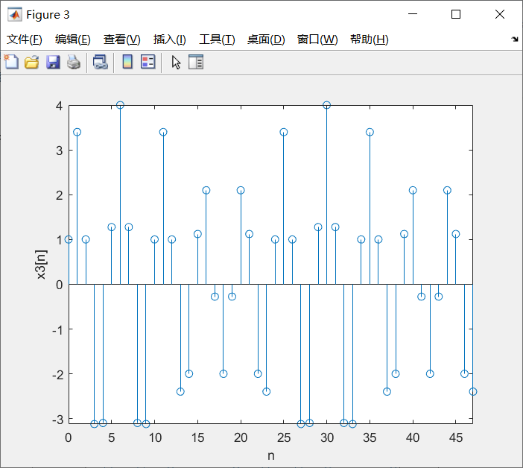

Figure 2.3 image of $x_{3}[n]$

MATLAB code:

% prob2.m

clc;

clear;

% x1[n] is periodic and its period is 12

figure;

n1=0:23;

x1=cos(n1.*pi/3)+2*cos(n1.*pi/2);

stem(n1,x1);

xlabel('n');

ylabel('x1[n]');

axis([0 23 -inf inf]); % Limit the range of abscissa

% x2[n] is not periodic, so we plot for 0<=n<=24

figure;

n2=0:24;

x2=2*cos(n2./3)+cos(n2./2);

stem(n2,x2);

xlabel('n');

ylabel('x2[n]');

axis([0 24 -inf inf]); % Limit the range of abscissa

% x3[n] is periodic and its period is 24

figure;

n3=0:47;

x3=cos(n3.*pi/3)+3*sin(n3.*pi*5/12);

stem(n3,x3);

xlabel('n');

ylabel('x3[n]');

axis([0 47 -inf inf]); % Limit the range of abscissa

**Problem 3**

Solutions:

1. By using MATLAB, we get the figures of the three signals as follows:

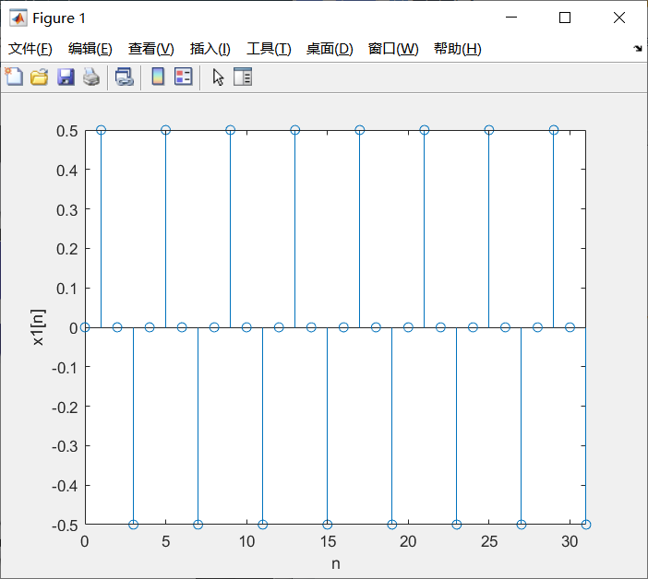

Figure 3.1 image of $x_{1}[n]$

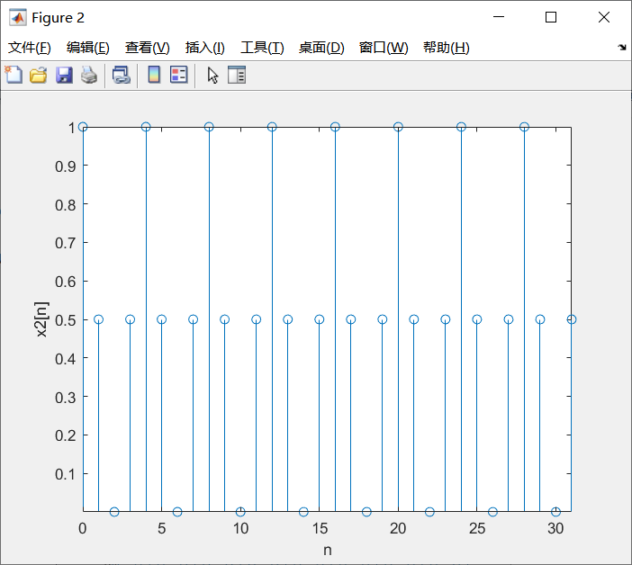

Figure 3.2 image of $x_{2}[n]$

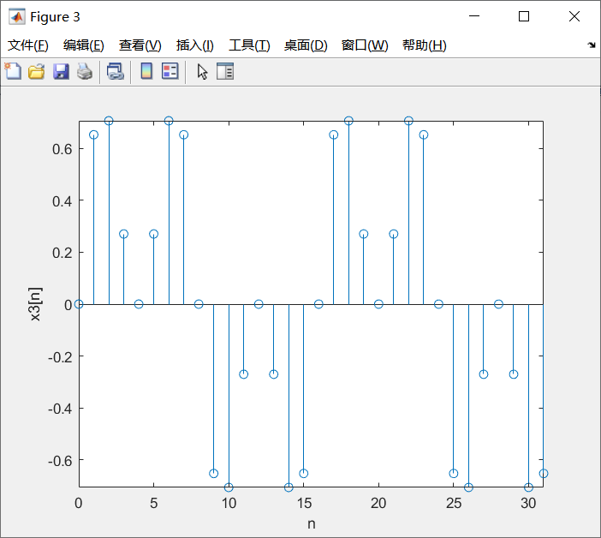

Figure 3.3 image of $x_{3}[n]$

And the fundamental period of each signal read form the figures is:

$$T_{1}=4,$$

$$T_{2}=4,$$

$$T_{3}=16$$

1. Since

$$x_{1}[n]=sin(\frac{nπ}{4})cos(\frac{nπ}{4})$$

$$x_{2}[n]=\cos^{2}(\frac{nπ}{4})$$

$$x_{3}[n]=sin(\frac{nπ}{4})cos(\frac{nπ}{8})$$

we have

$$x_{1}[n]=\frac{1}{2}sin(2×\frac{nπ}{4})=\frac{1}{2}sin(\frac{nπ}{2})$$

so the fundamental period of $x_{1}[n]$ is

$$T_{1}=\frac{2×2π}{π}=4$$

Similarly,

$$x_{2}[n]=\frac{1−cos(\frac{nπ}{2})}{2}=\frac{1}{2}−\frac{1}{2}cos(\frac{nπ}{2})$$

so the fundamental period of $x_{2}[n]$ is

$$T_{2}=\frac{2×2π}{π}=4$$

Since

$$x_{3}[n]=sin(\frac{nπ}{4})cos(\frac{nπ}{8})=\frac{1}{2}[sin(\frac{3nπ}{8})+sin(\frac{nπ}{8})]$$

and the periods of $sin(\frac{3nπ}{8})$ and $sin(\frac{nπ}{8})$ are $\frac{16}{3}$ and 16 respectively.

It is obvious that the result of $\frac{16}{3}÷16=\frac{1}{3}$ is a rational number, so the period of $x_{3}[n]$ is the least common multiple of $\frac{16}{3}$ and 16, that is,

$$T_{3}=16$$

MATLAB code:

% prob3.m

clc;

clear;

% calculate the values of each signal

n=0:31;

x1=sin(n.*pi/4).*cos(n.*pi/4);

x2=cos(n.*pi/4).*cos(n.*pi/4);

x3=sin(n.*pi/4).*cos(n.*pi/8);

% the figure of x1[n]

figure;

stem(n,x1);

xlabel('n');

ylabel('x1[n]');

axis([0 31 -inf inf]); % Limit the range of abscissa

% the figure of x2[n]

figure;

stem(n,x2);

xlabel('n');

ylabel('x2[n]');

axis([0 31 -inf inf]); % Limit the range of abscissa

% the figure of x3[n]

figure;

stem(n,x3);

xlabel('n');

ylabel('x3[n]');

axis([0 31 -inf inf]); % Limit the range of abscissa

**Problem 4**

Solutions:

1. No, the addition of two periodic signals is not necessarily periodic. For example, there are two signals as

$$y_{1}(t)=sin(t)$$

and $y_{2}(t)=cos(πt)$,

the least common multiple of their periods is $2π$.

We set $y(t)=y_{1}(t)+y_{2}(t)$

It is obvious that

$$y(t+2π)=sin(t+2π)+cos(πt+2π^{2})≠y(t)$$

so the answer must be no.

In addition, only when the ratio of the two periods is a rational number is the addition of the signals periodic. The proof is as follows:

Assume that $T_{1}$ is the period of $f(t)$, $T_{2}$ is the period of $g(t)$, and $T$ is the period of $f(t)+g(t)$. Since $f(t)+g(t)$ is periodic, we have:

$$T=k_{1}T_{1}=k_{2}T_{2}$$

where $k_{1}$ and $k_{2}$ are integers.

Therefore,

$$\frac{T_{1}}{T_{2}}=\frac{k_{1}}{k_{2}}$$

which is rational and $T$ is the least common multiple of $T_{1}$ and $T_{2}$.

1. No, the multiplication of two periodic signals is not necessarily periodic. For example, we set $z(t)=y_{1}(t)y_{2}(t)$, where $y_{1}(t)$ and $y_{2}(t)$ are signals in (a), so we have:

$$z(t)=sin(t)cos(πt)=\frac{1}{2}[sin(π+1)t+sin(π−1)t]$$

According to the theory in (a), since the ratio of the two parts’ periods is not rational, $z(t)$ is not periodic correspondingly.

**Problem 5**

Solutions:

1. In the figure plotted by MATLAB, we set

$$y_{1}[n]=sin(\frac{π}{2}x_{1}[n])$$

$$y_{2}[n]=sin(\frac{π}{2}x_{2}[n])$$

$$y_{3}[n]=sin(\frac{π}{2}x_{3}[n])$$

where $x_{3}[n]=x_{1}[n]+x_{2}[n]$.

The figure is as follows:

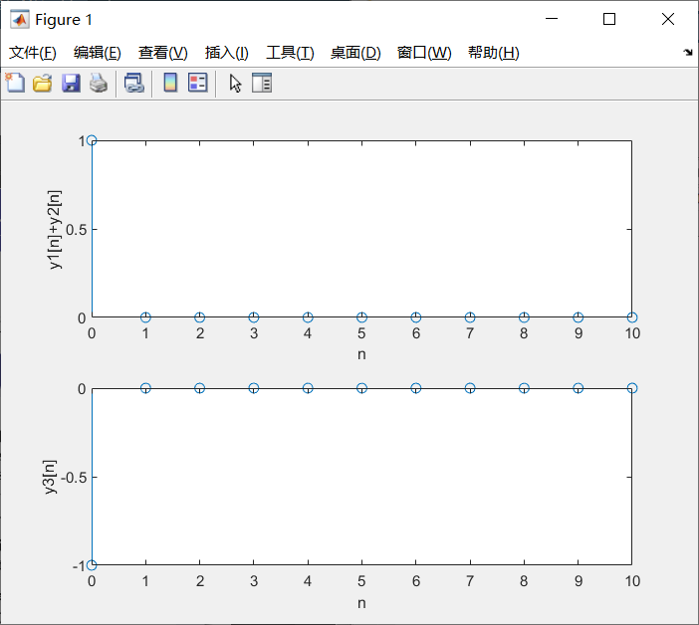

Figure 5.1 (a) linearity

It is obvious that $y_{3}[n]≠y_{1}[n]+y_{2}[n]$, which does not meet the definition of linearity, so this system is not linear.

1. In the figure we plotted by MATLAB, we find that at the point of $n=−1$, value of the input signal is 0, but value of the output signal is 1, which means the system’s output is not only determined by the inputs at present and past, but also by the input in the future. Through the system’s expression, we can figure it out as well. Since it dose not meet the definition of causality, the system is not causal.

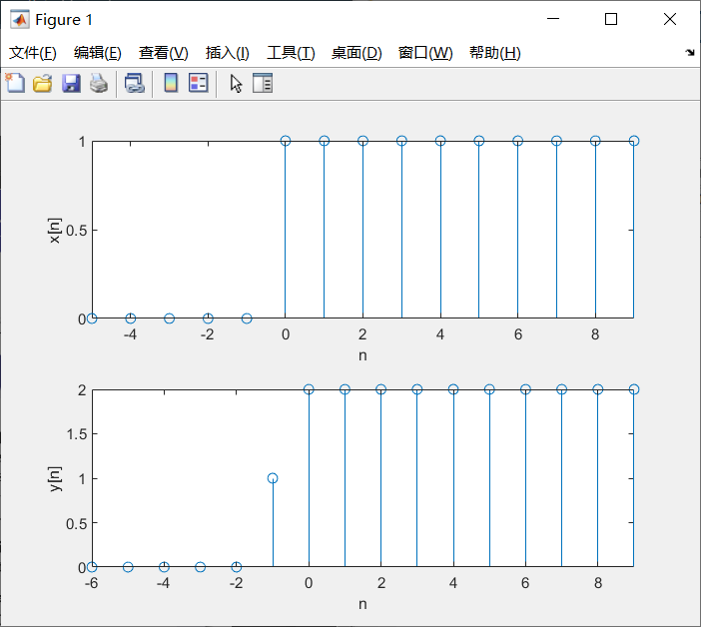

Figure 5.2 (b)causality

MATLAB code:

1. % prob5a.m

clc;

clear;

% prove nonlinearity

n=0:10;

x1=[1,zeros(1,10)];

x2=2*x1;

x3=x1+x2;

y1=sin(x1.*pi/2);

y2=sin(x2.*pi/2);

y3=sin(x3.*pi/2);

% plot y1+y2

figure;

subplot(2,1,1);

stem(n,y1+y2);

xlabel('n');

ylabel('y1[n]+y2[n]');

% plot y3

subplot(2,1,2);

stem(n,y3);

xlabel('n');

ylabel('y3[n]');

1. % prob5b.m

clc;

clear;

n1=-5:9;

n2=-6:9; % the range

% creat the unit-step signal, if n>=0, this function

% returns 1

z=inline('n>=0');

x=z(n1);

y=z(n2)+z(n2+1);

% the input signal

subplot(2,1,1);

stem(n1,x);

xlabel('n');

ylabel('x[n]');

axis([-5 9 -inf inf]); % limit the abscissa

% the output signal

subplot(2,1,2);

stem(n2,y);

xlabel('n');

ylabel('y[n]');

axis([-6 9 -inf inf]); % limit the abscissa

**Problem 6**

Solutions:

1. The MATLAB code for this function is as follows:

% deffeqn.m

function y=diffeqn(a,x,yn1)

N=length(x);

y(1)=yn1;

for n=0:N-1

y(n+2)=a*y(n+1)+x(n+1); % Eq.(1.6)

end

1. Using the function in (a), we get the figures for the unit impulse and unit step response respectively as follows:

According to the difference equation, we have

$$Y=RY+X$$

that is,

$$Y=\frac{X}{1−R}$$

so $y[n]=x[n]+x[n−1]+x[n−2]+……$

when the input is an unit impulse signal, the output is obvious an unit step signal for $0≤n≤30$;

Similarly, when input is an unit step signal, the output is an adder, which adds 1 to the value of each point for $0≤n≤30$.

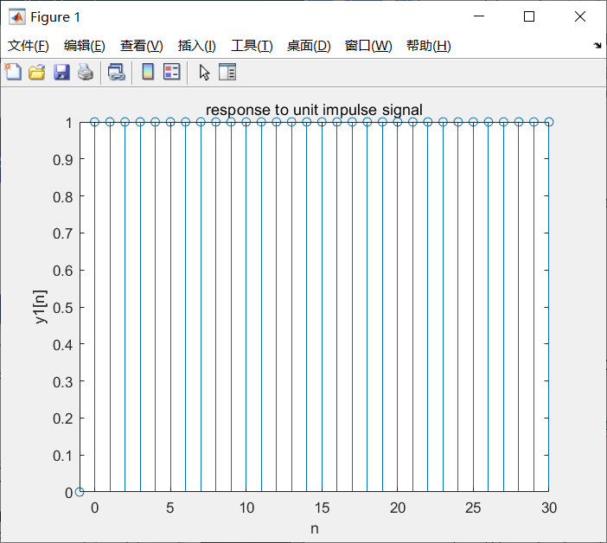

Figure 6.1 response to impulse signal

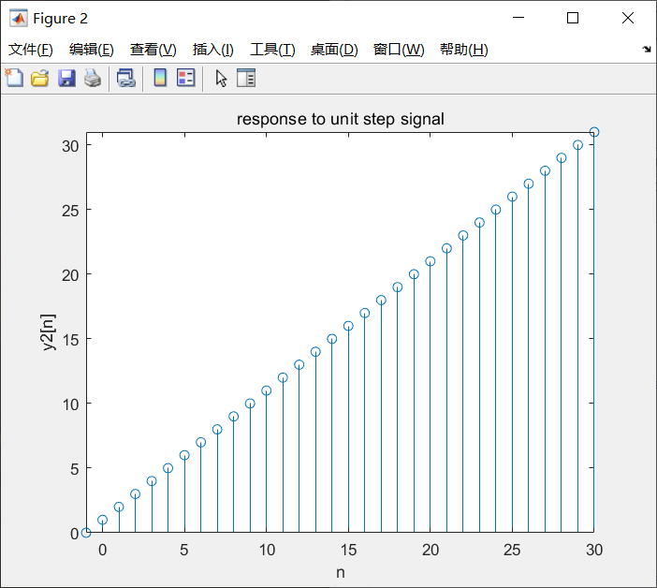

Figure 6.2 response to unit step signal

MATLAB code:

% prob6b.m

clc;

clear;

n=0:30;

a=1;

yn=0;

x1=[1,zeros(1,30)]; % unit impulse signal

x2=[ones(1,31)]; % unit step signal

y1=diffeqn(a,x1,yn);

y2=diffeqn(a,x2,yn);

% the unit impulse signal

figure;

stem(-1:30,y1);

title('response to unit impulse signal');

xlabel('n');

ylabel('y1[n]');

axis([-1 30 -inf inf]);

%the unit step signal

figure;

stem(-1:30,y2);

title('response to unit step signal');

xlabel('n');

ylabel('y2[n]');

axis([-1 30 -inf inf]);

**Problem 7**

Solutions:

By using MATLAB, we get a figure as follows:

According to the title,

$$x5=sin(\frac{2πt}{5})$$

whose period is

$$T=\frac{2π}{2π}×5=5$$

so we plot the curve between 0 and 10.

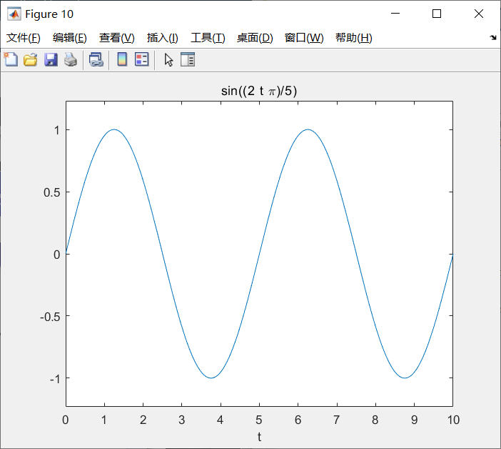

Figure 7 image of x5

MATLAB code:

% prob7.m

clc;

clear;

% create a symbolic expression

x=str2sym('sin(2*pi*t/T)');

x5=subs(x,'T',5); % substitute 5 for 'T'

ezplot(x5,0,10); % plot the expression for two periods

**Problem 8**

Solutions:

(d) The MATLAB code to store in $x$ a symbolic expression is:

x=str2sym('exp(i*2*pi*t/16)+exp(i*2*pi*t/8)');

(e) By using MATLAB, we get figures for the real and imaginary component of the signal as follows:

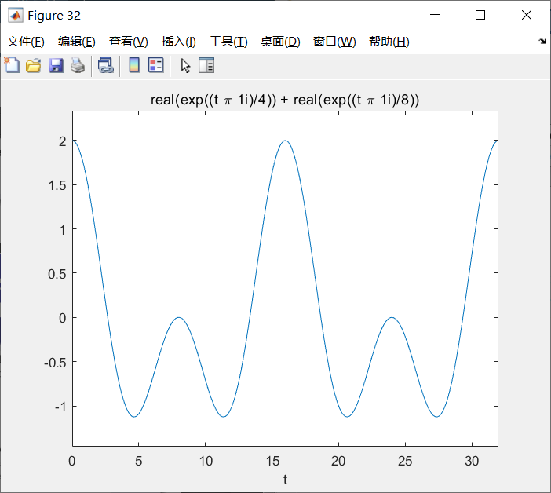

Figure 8.1 image of the real part

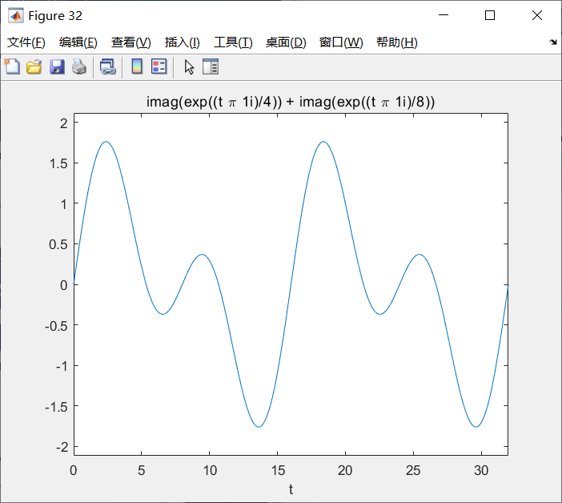

Figure 8.2 image of the imaginary part

From the figures, it is clear that the fundamental period of $x(t)$ is 16 $i$, and according to Euler formula, the real part of the signal is

$$Re\{x(t)\}=(cos\frac{πt}{8}+cos\frac{πt}{4})$$

while the imaginary part of the signal is

$$Im\{x(t)\}=(sin\frac{πt}{8}+sin\frac{πt}{4})$$

In addition, since

$$x(t)=e^{i2πt/16}+e^{i2πt/8}=e^{iπt/8}+e^{iπt/4}$$

and the period of the two parts are respectively $\frac{2π}{π}×8=16$ and $\frac{2π}{π}×4=8$, we can know that the fundamental period of the signal is the least common multiple of the two periods, that is,

$$T=16$$

which meets the result we get from MATLAB.

MATLAB code:

% prob8.m

clc;

clear;

x=str2sym('exp(i*2*pi*t/16)+exp(i*2*pi*t/8)');

xr=sreal(x); % get the real component of x

xi=simag(x); % get the imaginary component of x

% plot of the real part

ezplot(xr,0,32);

% plot of the imaginary part

% when need to draw the imaginary part, note off the

% following sentence

% ezplot(xi,0,32);

% sreal.m

function xr=sreal(x)

xr=real(x);

% simag.m

function xi=simag(x)

xi=imag(x);